# **Project Title**

TuneCraft - Dynamic Audio Control via 6D Object Tracking

# **Group Members**

Jose Conchello

Github Repo: https://github.com/conc2304/tune-craft-cv

# **Abstract**

TuneCraft is an innovative and immersive computer vision art project developed by Jose Conchello as the final project for DGMD E-14: Wearable Devices and Computer Vision, Fall 2023. The project leverages 6D object pose detection in real-time, and of real world objects, to dynamically control music parameters in Ableton Live, creating an interactive audio control environment. Utilizing computer vision techniques, TuneCraft enables users to manipulate audio outputs through physical movements and positioning of objects. This approach not only elevates the user experience in musical interaction but also establishes a novel interface between the physical and various forms of digital entertainment.

The backbone of TuneCraft comprises machine learning and computer vision tools, creative technology software suites, and projection hardware. At the core of the project’s functionality is Google’s MediaPipe Objectron solution for computer vision tasks such as 3D object tracking and estimation. TouchDesigner, a visual programming language used for creating interactive digital and physical applications, serves as the platform for connecting various processing pipelines as well as for developing the project's interactive user interface. Via 3D object pose estimation, these tools are used in conjunction to control and drive changes in music compositions in Ableton Live, a digital audio workstation known for its loop-based composition and real-time performance capabilities. Together with the computer vision tools, this creative technology suite forms the comprehensive technical framework that powers TuneCraft's interactive audio control environment.

# **Introduction**

This introduction aims to outline the foundational concepts, methodologies, and tools that form the core of the TuneCraft project. Later, we will delve into the roles of TouchDesigner, and Ableton Live, and additionally, how these diverse tools were connected together to collectively contribute to the project's unique interactive audio control environment.

TuneCraft, is first and foremost, an exercise in exploring the potential of using computer vision to drive more interactive and engaging art experiences that blur the lines of physical and digital by offering new perspectives on how we can approach user interface design in a world that heavily driven by screen based interactions or even worse, mouse and keyboard based interactions. The goal for TuneCraft is to re-imagine our relationship with how we interface with technology to imagine new possibilities of what the future of more human centric interactions can look like. To that end, TuneCraft creates a hybrid physio-digital approach to human-computer interaction through the manipulation of tangible, real-world objects, as the means to interact with technology.

More concretely, TuneCraft leverages the MediaPipe library to gather the real-time spatial positioning data of objects in an environment, in this case specifically a shoe, to then use that data stream to create an augmented reality projected user interface while simultaneously using that spatial data to control various parameters of a music composition within AbletonLive. Here a web camera, mounted onto a projector, sends a streaming video feed via TouchDesigner and into MediaPipe, which is then used to infer that spatial data that drives the whole experience.

At the heart of TuneCraft lies the integration of 6D object pose detection/estimation. 6D object pose detection, also known as 6D pose estimation, refers to the process of determining an object's position and orientation in three-dimensional space using computer vision and machine learning techniques. This involves identifying not only the XYZ coordinates of an object (representing its position in space) but also its orientation or rotation along three axes, often represented as pitch, yaw, and roll. This six-dimensional data (3 for position, 3 for orientation) allows for a comprehensive understanding of how an object is situated in a given environment, which is crucial for various applications including augmented reality, robotics, and interactive media. The goal of 6D pose estimation is to accurately and real-time track and interpret the spatial positioning and movement of objects within their environment.

Through the lens of this project, we will first examine the technical processes for how this can be accomplished and applied to a variety of projects. Additionally, we will examine the transformative potential of combining computer vision techniques with interactive digital media, highlighting the artistic and technical innovation that such a combination can bring about. TuneCraft is not just a project; it's a journey into the possibilities of how technology can enhance and expand the realm of creative expression.

# **Background**

In this background section, we explore the core technologies behind the TuneCraft project. We'll discuss the use of Google's MediaPipe for real-time 3D object detection and how its Objectron module aids in estimating object poses from 2D images. Additionally, we'll examine the challenges and solutions in 3D object detection, including the development of the Objectron dataset and the use of augmented reality for data annotation. We'll also cover the integration of MediaPipe with TouchDesigner for visual programming and Ableton Live for real-time music production, essential for TuneCraft's interactive and immersive audio-visual environment.

At the project’s heart is MediaPipe, an open-source framework developed by Google, designed to build pipelines for performing computer vision inference on a variety of sensory data, such as video or audio. MediaPipe Objectron is a mobile real-time 3D object detection solution for everyday objects. It detects objects in 2D images, and estimates their poses through machine learning models trained on the Objectron dataset. While object detection is an extensively studied computer vision problem, most of the research has focused on 2D object prediction. While 2D prediction only provides 2D bounding boxes, by extending prediction to 3D [Fig 1], one can capture an object’s size, position and orientation in the world, leading to a variety of applications in robotics, self-driving vehicles, image retrieval, and augmented reality. And although 2D object detection is relatively mature and has been widely used in the industry, 3D object detection from 2D imagery is a challenging problem, due to the lack of data as well as the diversity of appearances and shapes of objects within a category.

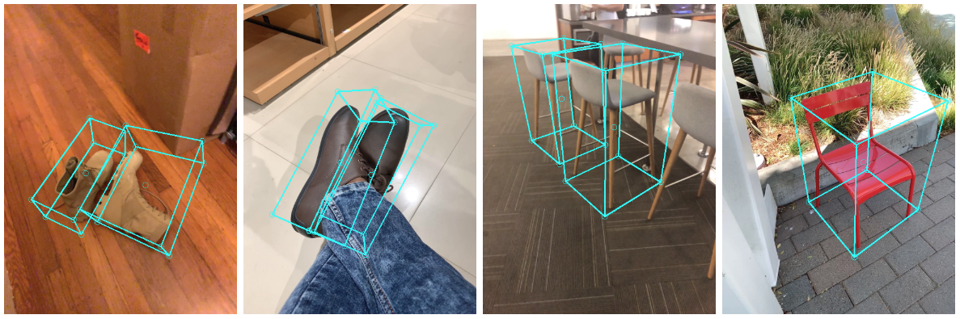

[*Fig 1. Objectron example results.*]

The principal way that Google got around the limitations caused by lack of quality labeled data was to create their own dataset, the Objectron Dataset [<https://github.com/google-research-datasets/Objectron>]. Despite the abundance of 3D data for street scenes driven by the self-driving car industry's reliance on 3D sensors like LIDAR, there are not many detailed 3D datasets for everyday objects with precise annotations. To bridge this gap, Google developed a data pipeline that uses mobile augmented reality (AR) session data. To facilitate the accurate labeling of this ground truth data, Google developed a unique annotation tool specifically designed for AR session data. Annotators can draw 3D bounding boxes within the 3D view and cross-check their accuracy against the 2D video frame projections. The process is streamlined for static objects; annotators need only mark an object once in a single frame, then its position is automatically updated across all frames using the camera pose data from the AR session. This approach significantly boosts the efficiency of their data annotation process leading to the best dataset around for 3D Object Pose Estimation.

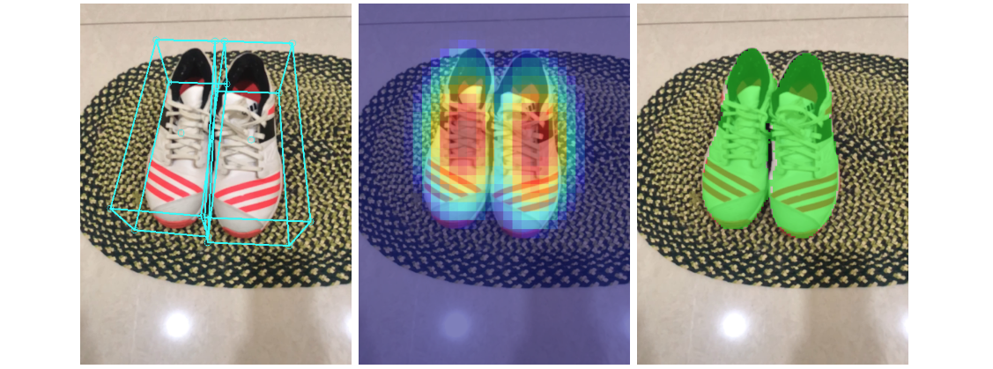

[*Fig 2. Sample results of Objectron network — (Left) original 2D image with estimated bounding boxes, (Middle) object detection by Gaussian distribution, (Right) predicted segmentation mask.]*

The Objectron dataset comprises a series of brief, focused videos capturing various objects, each accompanied by augmented reality (AR) session metadata. Augmented reality session metadata is essential for creating a coherent and immersive AR experience, as it allows virtual content to be accurately placed, oriented, and rendered in a way that is consistent with the real world. This metadata includes details such as camera poses, sparse point-clouds, and a description of planar surfaces in the vicinity. During each video, the camera circles the object, providing multiple angle views. Additionally, the dataset features manually annotated 3D bounding boxes for each object, detailing its position, orientation, and size. It includes around 15,000 video clips and over 4 million annotated images, covering categories like bikes, books, bottles, cameras, cereal boxes, chairs, cups, laptops, and shoes. To add geographic diversity, the dataset was collected from 10 different countries across five continents. Complementing the dataset, we've developed a 3D object detection solution for four specific object categories: shoes, chairs, mugs, and cameras. These models, trained using the Objectron dataset, are available in MediaPipe.

The choice to use MediaPipe for 3D object pose estimation in place of something like YOLO (You Only Look Once) object detection was due to the specific requirements and goals of the project, particularly regarding 3D understanding and real-time processing. YOLO is a powerful, fast algorithm primarily designed for 2D object detection. It excels at identifying objects and their locations within an image but doesn't provide information about their 3D pose (position and orientation in three-dimensional space). On the other hand, MediaPipe offers specific solutions like Objectron, which are designed for 3D pose estimation. This means MediaPipe can not only detect objects but also determine their 3D position and orientation, which is a crucial requirement for this project. Additionally, MediaPipe is engineered for real-time applications and is optimized to run efficiently on mobile devices and browsers. This makes it ideal for applications that require immediate feedback based on object interaction, such as augmented reality experiences or interactive media. For applications that require an understanding of an object's placement in a 3D space, like augmented reality or interactive installations, depth information is vital. MediaPipe’s 3D pose estimation solutions inherently provide this depth understanding, which YOLO does not. In summary, while YOLO is excellent for rapid and efficient 2D object detection, MediaPipe's capabilities in 3D pose estimation, real-time processing, and depth understanding make it more suitable for applications that require a comprehensive understanding of objects in a 3D space, as well as those that are interactive and AR-focused.

TouchDesigner is a versatile visual programming language designed for creating interactive 2D and 3D applications, installations, and multimedia content. Renowned for its ability to generate and render interfaces and graphics, TouchDesigner allows artists, programmers, and creatives to transform data into engaging displays and experiences. Its features facilitate communication between different systems and applications, making it an invaluable tool in complex multimedia projects. TouchDesigner's flexibility extends to its compatibility with Python, enabling users to run custom scripts, automate tasks, and integrate a vast array of functionalities. This integration of programming and visual design is crucial for developing real-time, interactive, immersive experiences. In the realm of computer vision, TouchDesigner's capabilities are particularly potent. It can process and visualize live data feeds, interact with sensors and cameras, and respond to user inputs in real time, making it ideal for projects that blend physical and digital elements. This makes TouchDesigner an essential tool for creating installations and performances that are dynamically responsive to their environment and audience. Its ability to merge artistic vision with technical execution defines TouchDesigner as a key player in the evolving landscape of digital art and interactive media.

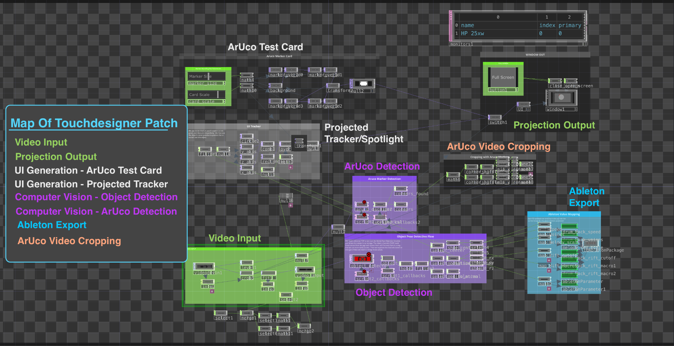

[*Fig 3: TouchDesigner’s node based visual programming interface*]

Ableton Live is a versatile digital audio workstation (DAW) known for its distinctive session view that facilitates on-the-fly music production and performance, allowing artists to mix, record, arrange, and edit in a non-linear fashion. It is widely used for its live performance capabilities and its extensive suite of instruments, effects, and audio/MIDI (Musical Instrument Digital Interface) processing features, making it a favorite among producers, DJs, and live performers. This enables artists to not only create and produce music but also to explore new soundscapes through its live session view, a feature that allows for the seamless triggering and manipulation of audio and MIDI clips in real-time. In this live session view , the series of vertical columns represent an individual track, which can contain multiple clips. Clips, which are the building blocks of a composition in Ableton Live, can hold musical phrases, rhythms, or any kind of audio/MIDI data, and are arranged horizontally across the tracks. They can be played individually or launched in combination to perform a piece of music.

Ableton Live is a comprehensive digital audio workstation (DAW) known for its unique session view [Fig 4], enabling spontaneous music production and live performance. Artists can intuitively mix, record, arrange, and edit, providing a fluid, non-linear creative environment. Renowned for its robust live performance tools and a rich array of instruments, effects, and audio/MIDI processing capabilities, Ableton Live is a staple for producers, DJs, and performers. Its session view, characterized by vertical columns for tracks and horizontal arrangements of clips—containing musical phrases or rhythms—allows for the real-time triggering and blending of these elements, crafting dynamic musical narratives. Ableton Live's flexibility is further enhanced by its ability to integrate with visual programming platforms such as TouchDesigner through the TDAbleton package [Fig 5], which is essential for projects like TuneCraft that require synchronized audio-visual interaction. This integration enables the seamless merging of sound with visual elements, allowing for a cohesive and interactive performance that is central to the immersive experience that TuneCraft aims to deliver. This deep level of granular integration of data driven parameter control via TDAbleton is one of the primary motivations for choosing Ableton as the DAW of choice for TuneCraft.

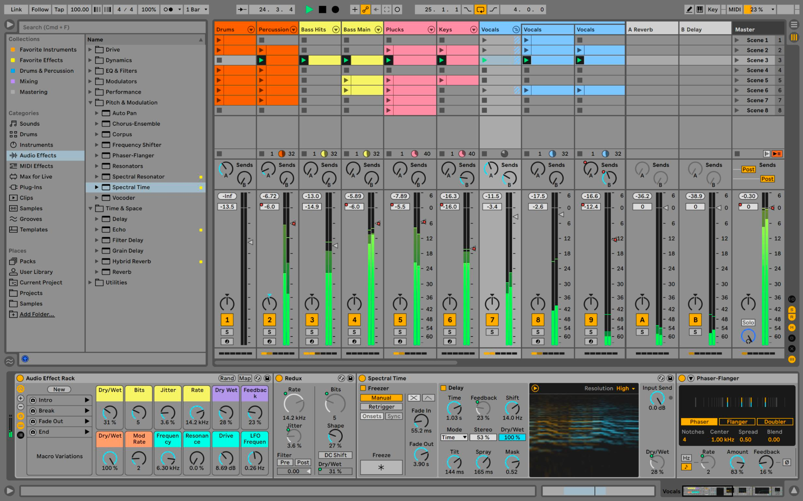

[*Fig 4: Ableton Live session view interface*]

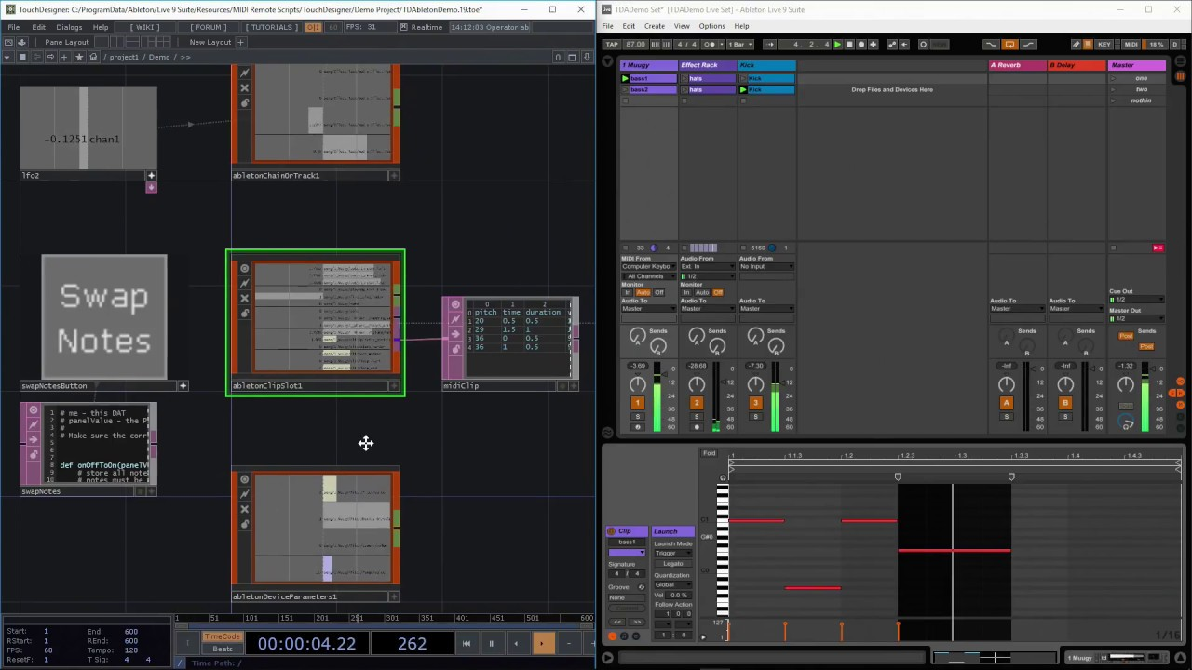

[*Fig 5: TouchDesigner’s TDAbleton package (Left)*

*and Ableton Live session view (Right)*]

In conclusion, the MediaPipe framework, with its Objectron solution for 3D object pose estimation, addresses the challenge of detecting and understanding objects in 3D space from 2D imagery. The integration of this technology with TouchDesigner and Ableton Live through the TDAbleton package, which facilitates the synchronized audio-visual connection that is pivotal for the immersive and interactive experiences that TuneCraft seeks to deliver. The project's reliance on Ableton Live, which allows for the fluid manipulation of audio and MIDI clips, is further justified by the need for real-time production capabilities, making it an ideal DAW for TuneCraft.

# **Methodology**

The approach for developing the TuneCraft application involved a series of multi-disciplinary technical steps. It starts with setting up a comprehensive virtual Python environment, followed by the processing of video feeds, fine-tuning our object detection pipeline for optimal performance, developing an interactive projected UI, and ensuring synchronization between the projector and camera systems for seamless integration.

# 

# 

[*Fig 6 methodology and process diagram*]

The initial step in deploying the TuneCraft project involved establishing a reproducible virtual Python environment compatible with TouchDesigner for running scripts that require external libraries. To manage this, the Anaconda platform was employed to handle project dependencies including OpenCV, MediaPipe, and Numpy as well as Python versioning, since TouchDesigner uses Python version 3.9. TouchDesigner needs to know where/how to access these libraries. To achieve this, a script dynamically sets the system paths based on the name of the Anaconda environment and user's computer name, which tells Touchdesigner where to look when we use these libraries in our scripts. This setup was necessary for processing and utilizing data within TouchDesigner to effect changes in both Ableton Live and the projected user interface.

With the Python environment established, next the video routing needs to be physically set up. For this, a web camera is mounted onto the projector that will be used for the UI projection. The optimal setup [Fig 7a] is for a vertically suspended projector to project perpendicularly onto the ground, however there is significant tolerance for less vertical arrangement [Fig 7b]. A video feed via a USB web camera is the starting point of the touchdesigner patch via the VideoDeviceIn operator. From there the video stream is split into two video routers. One will be the input data for the ArUco marker detection pipeline and the other will be a cropped version of the original video stream that is then sent to be processed for Object Detection [Fig 8]. The video stream that is going to the ArUco Marker detection pipeline is for the camera initialization process. The objective of this pipeline is to establish the boundaries of the projector in relation to the video feed. The markers [Fig 8 -left side] denote the corner edges of the projector, and while the camera has a broader field of view this creates misalignment between where the object is in the camera viewport versus where its relative projected position. Here OpenCV’s ArUco tools are used to identify the 4 corner markers, as values between 0-1920 for width and 0-1080 for height, the resolution / aspect ratio of both the camera and projector. While keeping the aspect ratio, those 4 corner markers are then used to crop the second video feed that will be used for Object Detection and Pose Estimation. Given the known dimension/resolution of the projector, we crop the video to the area containing all of the markers. With this cropping in place, the edges of the projection area are the same as the edges in the object detection input, meaning that an object detected at the edge of the camera aligns to the edge of the projection. From here, that cropped video is then sent through the object detection pipeline.

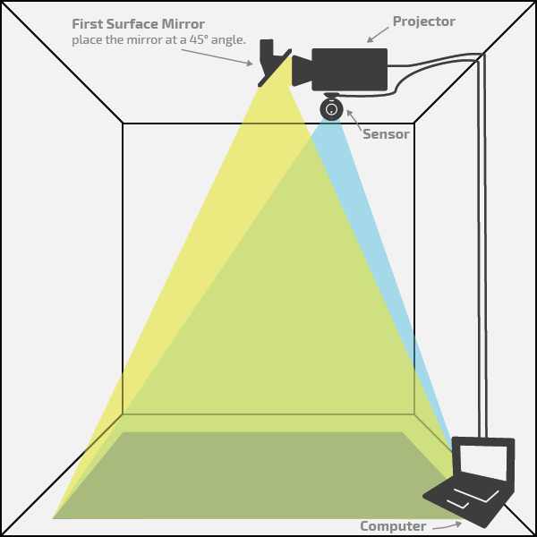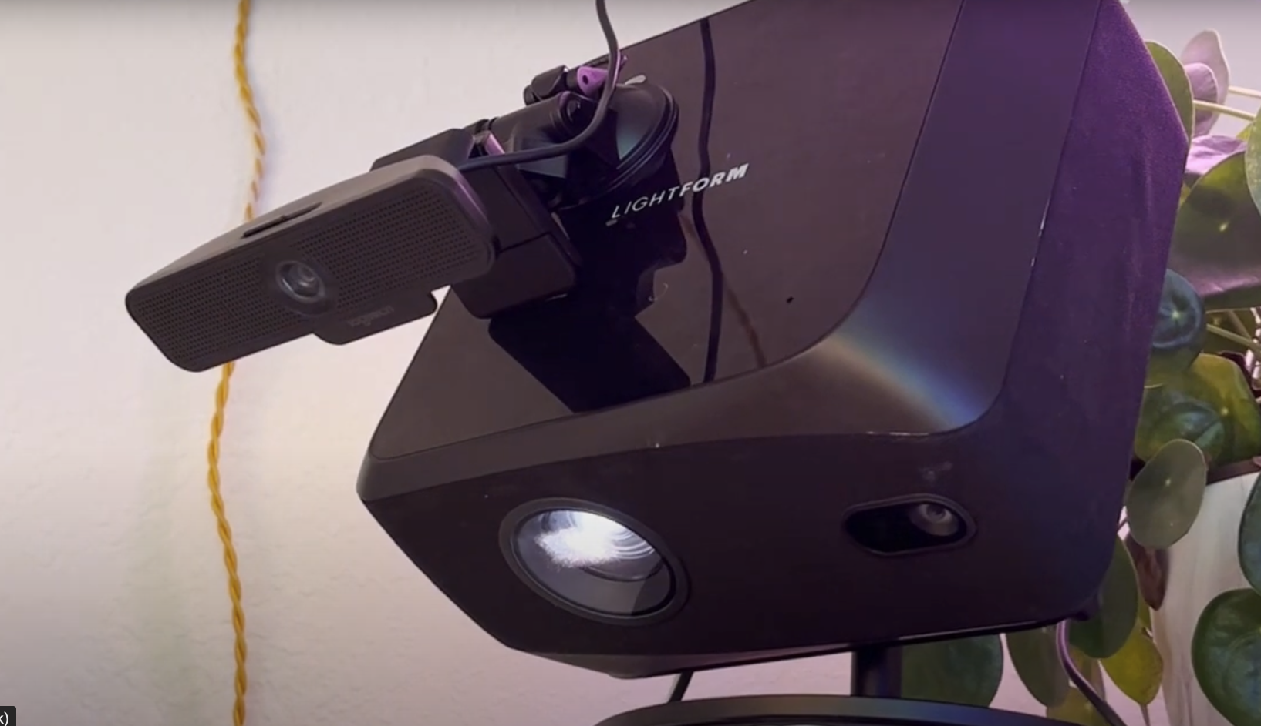

[Fig 7a (Left): Optimal projection and camera orientation;

7b (Right): Actual projector orientation with mounted web camera. ]

The cropping of the video is not just done for the mapping of the camera input to the projector output, this also helps to optimize our object detection pipeline as we are sending less pixel data that needs to be processed. To further optimize, we then refit/scale the cropped video stream to a smaller scale, while preserving the aspect ratio. Specifically, we halve the the scale of the video which means that now there are substantially less pixels/data that Objectron has to parse which leads to a more fluid real-time tracking experience.

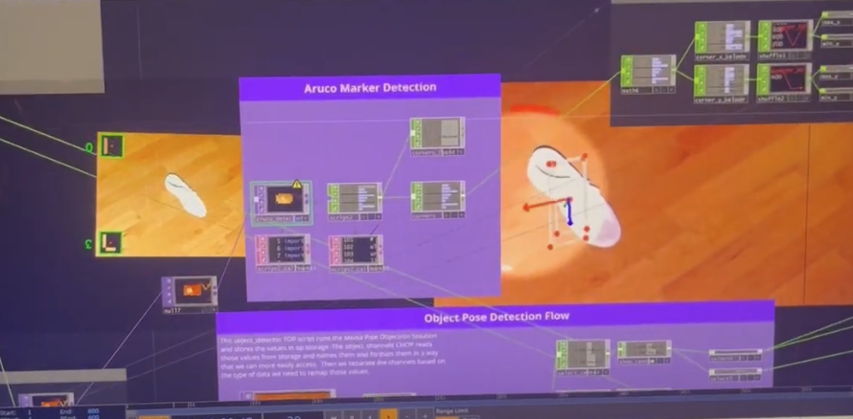

[*Fig 8: ArUco detection of projected markers as the bounding box (Left side video).*

*Cropped video stream of object detection (Right side video)*]

Now in our primary feature script inside of Touchdesigner, this python script is executed inside the onCook callback of the Touchdesigner Script operator. The onCook method is triggered whenever a node (also known as an operator or 'OP') needs to update or process its data. This could be due to changes in input data, parameters, or other factors that require the node to refresh its output, in this case every new video frame is the change in data that triggers the onCook to run. This Script Op is running the `object-pose-detection.py` script located in the touchdesigner directory of the repo. At a high level that script uses OpenCV to preprocess the image data as a numpy array by first doing color correction, conversion, normalizing RGB values, and converting the datatype of the channel values of the image array to be usable by Media Pipe, in this case to an 8 bit unsigned integer from a 32 bit float. This file also configures how the Objectron solution will run as well as what object types it should track.

The Objectron API operates in two modes: 'static_image_mode' for analyzing each image separately, ideal for static images, and a video stream mode for continuous tracking with reduced latency, suitable for videos. Typically, one would not use the static_image_mode for videos. However, due to the fact that a while loop (how the cv3.capture() method is expected to run for video feeds), in TouchDesigner’s synchronous environment, blocks other application executions, we run the solution in static image mode. Other parameters that we use in the solutions are 'max_num_objects' , 'min_detection_confidence', 'min_tracking_confidence' , and 'model_name' with options like 'Shoe', 'Chair', 'Cup', and 'Camera'. For the sake of faster response times, and to reduce lag, we have the maximum number of objects set to 1, and the detection confidence set to 0.2 (from 0-1) which might pick up more unintended objects, but is more likely to find the target object in an otherwise empty environment. Setting the detection confidence higher (0.7 - 1) causes notable laggy/sporadic detections on the lower end, and at the higher end it tends to not even be able to find the target object. The ‘min_tracking_confidence’ property is the confidence threshold (0.0 to 1.0) for successful landmark tracking. A higher value increases robustness but adds latency. In static_image_mode (as in our case), this is ignored as detection runs on every image. Objectron then returns a list of 3D bounding boxes for each detected object, including 2D and 3D landmarks normalized and represented in the camera coordinate frame [Fig 9], as well as the object's rotation matrix, translation vector, and relative scale in the x, y, and z directions. Objectron gives us simple to interpret values for the positional data’s X, and Y values, but the rotational values are given as a rotation matrix. That matrix is then used to calculate the X, Y, and Z rotational values that will then drive other audio/visual outputs. Once the object detection pipeline is complete, that data is exported from the Script Op and routed to two separate pipelines: one for driving the projected UI and the other for driving the ableton live parameters.

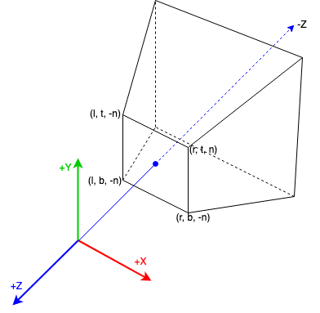

[*Fig 9: The Objectron API uses the above camera coordinate definition, with +x pointing right, +y pointing up and -z pointing to the scene.*]

For the data route that is going to Ableton, each 6D detection value is remapped to the minimum and maximum of each Ableton Live parameter [Fig 10], each of which has their own value space (ie, the Drum Track has 8 clips so we remap the centroid range of 0 to 1 to be from 0 to 8). Objectron returns the positional data to us as landmark values between 0 and 1, and we have previously mapped the returned rotational matrix into individual rotational values as degrees from 0-360. The other data route goes to the projection UI pipeline. This pipeline is responsible for taking the object’s positional and rotational data and creating and rendering a simple interface as visual feedback of the object’s position in space. The X, Y position data are visualized as a spotlight over the object, and the rotational data is visualized as 3 red, green, and blue arcs of concentric circles that orbit the spotlight [Fig 11]. This allows us to visualize the 360 degrees of rotation of the object using the position of the arc in the circle similar to a clock hand. From here, this UI is output as a video feed to a video switching operator. The video switching pipeline first determines whether we have already gotten our projector’s bounding area via the ArUco detection script. If it does not see that we have that data available it will render the ArUco test card, but if we have already done that it will send the Object Detection UI through to the projector.

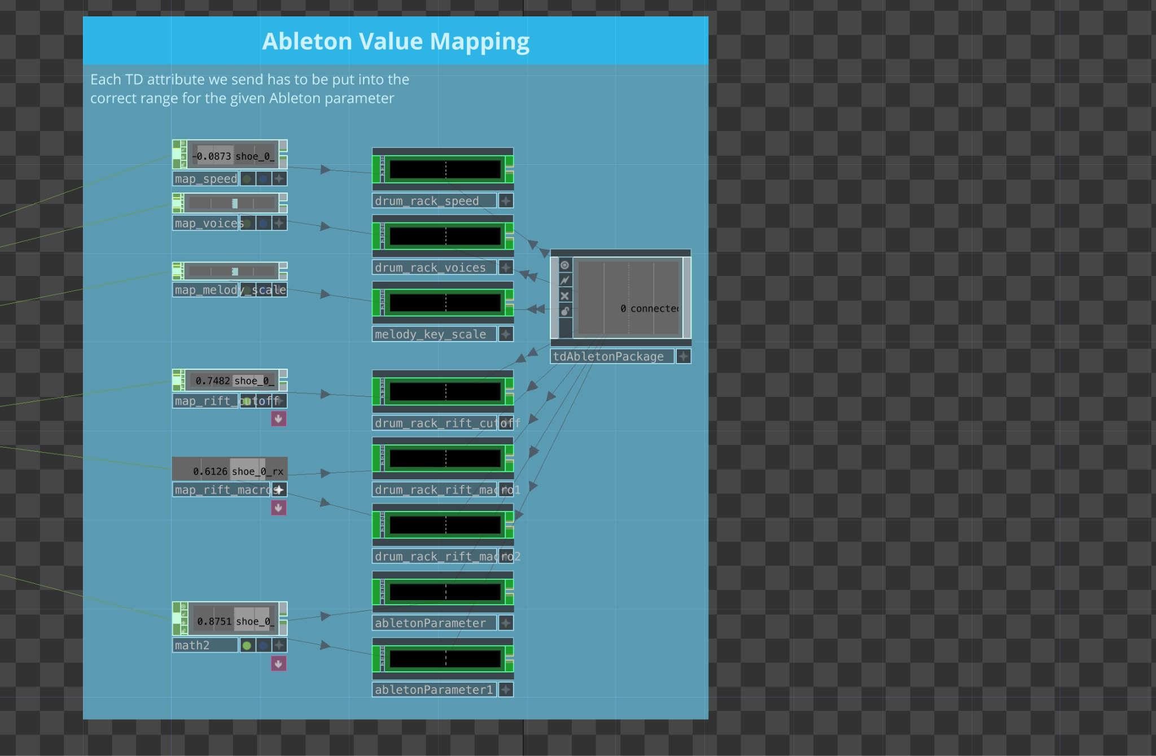

[*Fig 10: Implementation of TDAbleton package and remapping Objectron’s detection results to the individual Ableton parameter ranges]*

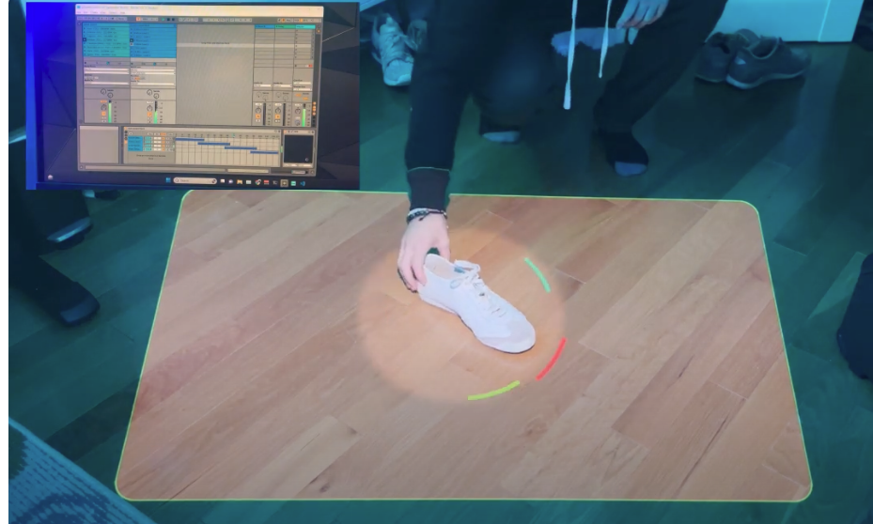

[*Fig 11: Spotlight tracking via Objectron centroids X,Y, & Z rotation represented by the respective red/green/blue arcs around the spotlight*]

At this point a user moving a shoe within the projection boundary should hear changes to the audio being generated as well as the UI being projected. The object’s Y position controls which of the 8 unique drum loops to play. The object’s X position controls which unique instrument [Fig 12] (i.e. piano, tuba, violin …) is used in the selected melody clip [Fig 11; Blue Column]. The objects rotation values for X, Y and Z respectively control the melody clip selection, tempo [Fig 13] (aka Beats Per Minute), amount of reverb & delay to apply as an effects filter [Fig 13].

# 

[*Fig 11:Drum loop clip controlled by object’s X position (Left Green Col); Melody loop clip controlled by object’s X rotation (Right Blue Col)* ]

# 

[*Fig 12: Each of the 4 melody instruments are mapped to a specific range as the blue horizontal bars. Current instrument selection is denoted by the light blue marker above. Instrument selection is controlled by objects Y position* ]

# 

[*Fig 13: UI indicator for temp/BPM (Left),*

*UI indicator for reverb/delay effect amount (Right)* ]

# 

# **Results**

There were several key results that were discovered through the experimental nature of the TuneCraft project. Most notably is that the project successfully demonstrates the integration of computer vision and 6D object pose estimation in the realm of interactive digital media which can lead to more innovative ways to think about human-computer interactions. Additionally, this project was successful in creating a real time musical instrument and environment through the use of 3D object pose estimation that breaks away from conventional ways of interacting with music.

A notable result and shortcoming of the project are the unstable and noisy rotational data that we receive from Objectron which relates to using the MediaPipe Python package for running the code within TouchDesigner. It was not discovered, until too far into the project to pivot, that because of how the video feed system works in passing frame data to the TouchDesigner Script Op that is running Objectron (to the best of my current knowledge); Objectron in ‘static image mode’ leads to less confident and noisy rotation results. One possible way to mitigate or bypass this bottleneck, while still executing within TouchDesigner to have access to the detection data in real time, would be to run a web server inside of TouchDesigner and use the Javascript Solutions API instead. By using the Javascript Solution in a web server, we are able to harness Javascripts ability to run code asynchronously, which (to the best of my current/limited knowledge of running Python scripts within TouchDesigner) is not feasible.

That being said, the real-time processing of video data to drive changes in audio output and visual projections creates an accessible process to leverage other computer vision toolchains to create dynamic interactive environments. The success of this project is in its ability to create an interactive and engaging environment which can be attributed to its blend of the technical ecosystem, showcasing the potential of computer vision in transforming the landscape of digital art, interactive media, and computer interfaces.

The results of the TuneCraft project were notably impactful, demonstrating a successful integration of computer vision with interactive audio control. By leveraging the capabilities of TouchDesigner and Ableton Live, along with MediaPipe's Objectron for 6D object pose estimation, the project achieved a high level of interactivity and immersion.

There are however some shortcomings to the project. The first of note is that Media Pipe’s Objectron Solution is only trained on 8 specific objects, which limits the variety of objects that we can interact with. At the time of this writing, Media Pipe has not released its training model or process for training the Objectron Solution to detect new objects. Compute power and the synchronous executing nature of both Python and Touchdesigner became performance bottlenecks. Despite running on a Nvidia GPU, the program execution would cause lags in the system, which is primarily felt through projected UI lag.

# **Next Steps**

Given that a lot of the shortcomings and limitations are able to be resolved via code, the next steps would be to address those shortcomings. One way to resolve the compute power limitation introduced by the synchronous nature of Python and Touchdesigner would be to use MediaPipe’s Javascript Api instead of their Python Api. Since that part of the pipeline is already a self-sustaining module, that entire Python workflow module could be hot-swapped with a web server based one. By using the Javascript API, this would allow us to run the same detection solution but via an asynchronous web server. This, however, would need to be tested since Javascript is not known for its fast compute time relative to other languages despite the recent introduction of the WebGPU API intended for Javascript processes to run on the GPU. From the web server, running in Touchdesigner, the data could be transmitted and read via web socket operators and then continue through the rest of the already established pipelines making it a very easy swap.

Another future improvement would be to expand the ability of the program to accurately recognize and estimate more objects. This could, in turn, offer more ways to interact with TuneCraft where different items could control different experiential settings like music parameters or other things. In order to use more objects outside of the 4 objects that MediaPipe uses in its basic solutions would require additional work in creating new models to train and validate against other objects that are in the Objectron dataset that are not part of the bootstrapped detection solution (bikes, books, bottles, cereal boxes, cups, and laptops). Even further beyond this would be to go beyond the objects that are part of the Objectron dataset and use the tools and processes that MediaPipe created to more quickly manually annotate data using their AR Synthetic Data Generator to quickly label 3D bounding boxes for objects.

A current limitation that is out of scope for this class project is the projector’s position and orientation. Currently the UI mapping operates best when the projector is as perpendicular to the projected surface, and as squarely aligned with the camera as possible. With lower projection angles the positional data that is read is currently not re-skewed to conform to the topography of the projected surface causing more misalignment the more horizontal the projector is to the floor. This misalignment could be resolved at higher angles by applying a transformation matrix to the projected UI that matches the skewing caused by the angle of the projector. While some of these limitations are due to hardware, other limitations or shortcomings can be resolved in code in the future.

With this system in place and tested for feasibility, other computer vision pipelines can be substituted for the current 6D pose detection to create a variety of different types of immersive art installations and activations that could be driven by things like human poses, facial expression, and more.

# **Conclusion**

The TuneCraft project, developed as a part of the DGMD E-14 course, stands as an exploration in the integration of computer vision and creative technology, specifically for controlling music in real time in an interactive media environment. At its core, the project utilized TouchDesigner and Ableton Live, with MediaPipe's Objectron for 6D object pose estimation, to create an immersive audio-visual experience. The system allowed real-time manipulation of audio outputs in Ableton Live based on the physical movement and positioning of objects, tracked using MediaPipes’ Objectron through a webcam and processed by computer vision algorithms. This, in turn, creates the possibility to expand on these concepts and prototypes in the future.

The key takeaway from TuneCraft is the demonstration of how computer vision can revolutionize interactive media and digital art. The successful implementation of this project showcased not only technical proficiency but also creative innovation. The real-time processing of visual data to influence and control music parameters resulted in a highly interactive and engaging user experience. The project's impact lies in its potential as a blueprint for future explorations in the field, where such technology can be further harnessed to expand the boundaries of artistic expression, immersive performances, and interactive installations.